|  |
| --- |
| Name: H.P.M.I.U.Rathnapriya |
| Student Reference Number: 10899677 |

**Group 55**

|  |  |
| --- | --- |
| Module Code: PUSL2021 | Module Name: Computing Group Project |

|  |
| --- |
| Coursework Title:(Group A ) Project Proposal |

|  |  |
| --- | --- |
| Deadline Date: Wednesday,25  October 2023 , 3.00 PM | Member of staff responsible for coursework:  Mr. Pramudya Thilakarathne |

|  |
| --- |
| Programme: BSc.(Hons.) Software Engineering  Please note that University Academic Regulations are available under Rules and Regulations on the University website [www.plymouth.ac.uk/studenthandbook](http://www.plymouth.ac.uk/studenthandbook). |

|  |  |  |  |  |  |  |
| --- | --- | --- | --- | --- | --- | --- |
| |  |  |  | | --- | --- | --- | | Names | Plymouth ID No | Leadership | | * H.P.M.I.U.Rathnapriya * P.A.U De Silva * M.V.M Denawaka * M.D.M Rathnayake * N.K.D Mithila * K.D Mundigala | * 10899677 * 10898667 * 10899500 * 10900371 * 10898549 * 10899622 | * Project and Group Leader * Planning Leader * Technical Leader * Programming Leader * Quality Leader * Testing and Maintenance Leader |   Group work: please list all names of all participants formally associated with this work and state whether the work was undertaken alone or as part of a team. Please note you may be required to identify individual responsibility for component parts.  ***We confirm that we have read and understood the Plymouth University regulations relating to Assessment Offences and that we are aware of the possible penalties for any breach of these regulations. We confirm that this is the independent work of the group.***  Signed on behalf of the group: |
| Individual assignment: ***I confirm that I have read and understood the Plymouth University regulations relating to Assessment Offences and that I am aware of the possible penalties for any breach of these regulations. I confirm that this is my own independent work.***  Signed : |
| Use of translation software: failure to declare that translation software or a similar writing aid has been used will be treated as an assessment offence.  I *have used/not used translation software.  If used, please state name of software………………………………………………………………… |

Table of Contents

**Overview1**

**Overview and Introduction**

**Objectives**2

Providing quality guidance to higher education aspirants

Helping candidates to find the right job

Finding Projects and Internships

**Target Audiences** 3

**Features** 4

**Features** 5

**Technology and Tools**6

Gantt Chart

References

**Overview**

Our service provides students who wish to enroll in their higher education with comprehensive guidance in the field of education they need and a good understanding of the educational scopes that suit the modern job market. Also, information about post-graduation programs and job aspirants will give them the opportunity to find jobs that match their educational qualifications and get a better understanding of those jobs.

**Introduction**

This web application minimizes the difficulty of students getting proper information about the subjects and universities that suit them for their higher education and comparative information about the demands of those subjects in the modern job market. This also informs the students about the important points in choosing their field of higher studies, the quality of the field they have chosen and the degree programs related to that subject, and the universities that offer those degrees are given to the user. This web application provides an opportunity to select universities by providing other factors such as cost, university location, and campus culture. This web application stays in touch with the user from the beginning of the process to help them choose the right scope for their personal needs and goals. Students who want to access their higher education are given detailed guidance on the best domestic and foreign universities to pursue higher education and academic subjects relevant to their preferred field of study and the modern job market. All of these processes ultimately encourage the user to make informed decisions about their higher education. Also, job seekers can search for jobs that match their educational courses, get comparative information about those jobs, and apply for those jobs through this application. The web application also provides undergraduate students with a dedicated page for internships to select internships recommended during their degree and graduate students with up-to-date recommendations from subject matter experts in selecting their post-graduate programs.

**Objectives**

1. **Providing quality guidance to higher education aspirants:**

* The main objective of this application is to provide students who have no proper idea about higher education after completing their secondary education to make informed decisions for their higher education through this web application. Here, based on the data and information obtained from the user, the basic arrangement needed to start their higher education is created according to the capabilities of each user. This web application provides up-to-date information to the students from which fields to start their higher education, degree programs to choose from, degree levels, suitable universities, world rankings of those universities, and a comparison of the selected programs with the modern job market.
* Furthermore, the students can get a good idea about their decisions through the updated reviews of the subject experts and the students who have studied those programs about the degree programs, degree levels, and selected universities.

1. **Helping candidates to find the right job**

* Candidates can find the right jobs and find the best and most suitable job that matches their skills according to their personal needs and career goals, this helps them enjoy their career without regrets and achieve and find their financial goals. For example, after entering your qualifications, you will receive job opportunities and their reviews that match your qualifications.

1. **Finding Projects and Internships**

* Empowering undergraduates through this web application not only eases the journey of higher education but also significantly contributes to their learning and problem-solving abilities. Consider a student enrolled in computer science, who serves as a valuable resource for things like group projects and programming.
* This helps to make the work easier for undergraduates. This helps to contribute to learning and solve learning problems. For example, an information seeker can come to this web application and get whether he is eligible to study in undergrad.
* This will be very helpful for a knowledge seeker and to acquire the required knowledge. Help solve problems in programming, solving problems in group projects.

**Target Audiences**

1. **Students:** High school students, college students, and students who have completed their secondary education and are about to start higher education.
2. **Parents:** Parents who wish to get accurate and updated guidelines for their children's future higher education
3. **Job Seekers:** Those who have completed their higher education and are eager to find a suitable job that matches their educational qualifications.
4. **Undergraduates:** Students seeking information for coursework projects during their degree and students seeking internships for degree-recommended internships.
5. **Graduates:** Graduates looking forward to starting their post-graduation and graduates looking to go abroad for their post-graduation.

**Features:**

1. User registration and login functionality:

* Here the user can register and create an account and log in to their account as per the requirement.

1. Personal account management:

* The data and information in the account created by the user has the ability to update the information as and when required by the user. The user's account also has personal information management functions.

1. User data filtering functionality

* Here the relevant data of the user is obtained through a small questionnaire and the data is filtered by the web application. It gives the desired output to the user.

1. Data Privacy:

* Privacy protection is provided to users' personal information and personal information obtained by users. The information is guaranteed not to pass into the hands of a third party

1. Feedback showcase and Reporting

* Continuous improvement based on reviews and user feedback of our web application. , The reporting tool is presented to identify bugs in our web application

1. Comprehensive analysis:

* This enables the user to compare the higher education path he chooses with the current job market so that he can make his final informed decision.

1. Community forum:

* This allows users to ask their questions and get answers from subject matter experts

1. A blog and newsletter:

* Here users can publish articles related to the topic of higher education and employment and can also be updated about the news related to this topic.

1. mobile responsive

* This web application is designed to be responsive to any mobile device

**Technology and Tools**

* React js – Frontend
* node.js- backend
* SQL – Database
* Figma – UI/UX

Programming languages

* JavaScript
* Html
* CSS
* Python

**Gantt Chart**

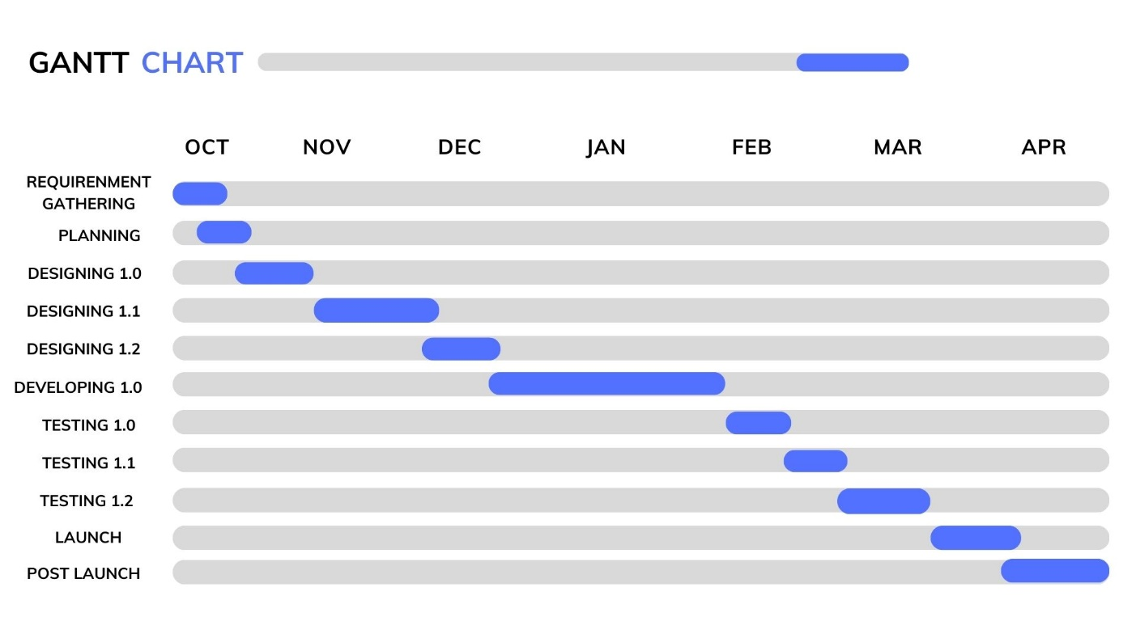

**References**

1. <https://www.bestcolleges.com/school-search/>
2. <https://www.zippia.com/?survey_step=step3&survey=036&skipQuestion=1>
3. <https://www.reddit.com/?rdt=63771>
4. <https://plymouth.ac.uk/>